

S. Y. B. Tech (AIDS)
Project 1 [Theory of Computation - MT24AI02A]
ANTI-GRAVITY ELEVATOR

By
Pravesh Jain - 31240451
Vandith Shetty - 31240252
Gagan Agrawal – 31242676
Aarushi Jain – 31240797
Palak Thakur - 31240928

2025-2026
Pursued in
Department of AIDS Faculty of Science & Technology Vishwakarma University, Pune

Problem Statement
Design a finite automaton for an elevator system operating in a building with N floors. The elevator can move up, down, and stop at each floor. The automaton should:
• Start at an initial floor,
• Transition between floors based on user input (UP, DOWN, STOP),
• Detect invalid transitions (e.g., moving up from the top floor or down from the ground floor).
Construct the state diagram and explain the transition rules.

1. Introduction
An elevator control system can be modeled using concepts from Automata Theory, specifically Deterministic Finite Automata (DFA). A DFA is a mathematical model used to represent systems with a finite number of states and deterministic transitions based on inputs.

This report presents the design, formal specification, and implementation of an Anti-Gravity Elevator Deterministic Finite Automaton (DFA) Simulator. The project models a five-floor elevator system operating in a zero-gravity (zero-G) space environment, where traditional physics such as gravitational pull, ground-floor asymmetry, and passive descent are absent.

The core of the simulator is a mathematically rigorous DFA — a formal model from the Theory of Computation — that captures all valid states of the elevator (floors F1 through F5) and an error (trap) state triggered by out-of-boundary commands. A React-based interactive simulator visualises the automaton with a space-station aesthetic, complete with thruster animations, orbital state diagrams, and breach-alert warnings.

This report explains every part of the project: the DFA formal definition, the JFLAP state diagram, the transition table, minimality proof and simulation dashboard components.

2. Formal DFA Definition
A Deterministic Finite Automaton is defined as a 5-tuple M = (Q, Σ, δ, q₀, F), where each component is formally specified below.

2.1 The 5-Tuple Definition
Component | Symbol | Definition
Set of States | Q | { q0, q1, q2, q3, q4, q5 } → floors F1–F5 plus error state q_err
Input Alphabet | Σ | { UP, DWN, STP } → thruster up, thruster down, magnetic stop
Transition Function | δ | δ: Q × Σ → Q (total function — defined for all 18 state–input pairs)
Start State | q₀ | F1 (Floor 1 — Entry Hatch)
Set of Accepting States | F | {F1, F2, F3, F4, F5} → all floor states (not q_err)
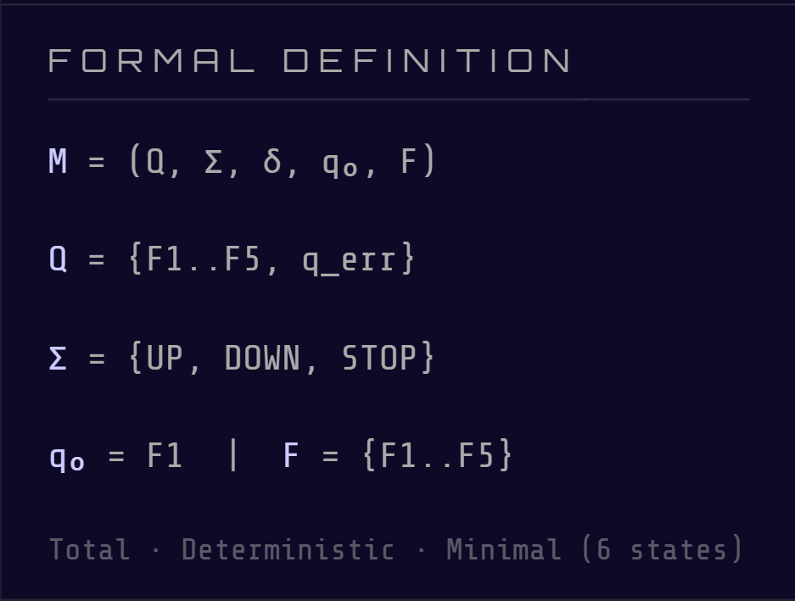

2.2 State Semantics
In the zero-G model, all floor states are symmetric — no floor has a 'natural' gravity advantage. The states are reinterpreted as docking positions inside a zero-gravity containment vessel:

State (JFLAP) | Floor | Zero-G Label | Description
q0 | F1 | Entry Hatch | Lowest docking port — the initial state (q₀)
q1 | F2 | Low Orbit Bay | First internal docking ring
q2 | F3 | Mid Bay | Central docking ring — symmetry point of the vessel
q3 | F4 | High Orbit Bay | Upper docking ring
q4 | F5 | Apex | Highest docking point — upper airlock boundary
q5 | q_err | Hull Breach | Trap state — catastrophic failure; absorbing and non-accepting

2.3 Input Alphabet Reinterpretation
The three input symbols from the JFLAP diagram map to physical commands on the zero-G vessel:
- UP — Fires an upward thruster burst, drifting the capsule to the next higher floor.
- DWN (DOWN) — Fires a downward thruster burst, drifting the capsule to the next lower floor.
- STP (STOP) — Deactivates all thrusters and engages magnetic docking clamps, holding the capsule at its current floor (self-loop).

3. JFLAP State Diagram Explained
The JFLAP screenshot shows the complete DFA visualised as a directed graph. This section explains every element visible in the diagram.

3.1 Overview of the Diagram
The diagram is displayed in JFLAP's Nondeterminism panel, which highlights any nondeterministic states in red. Since all states are yellow (no red highlighting), this confirms the automaton is fully deterministic — there are no ambiguous transitions.
The diagram contains six circular nodes (states): q0, q1, q2, q3, q4 arranged in a horizontal chain, and q5 positioned below as a sink/trap state. Arrows (transitions) connect them according to the transition function δ.

3.2 The State Nodes
Node | Colour | Shape | Meaning
q0 – q4 | Yellow fill | Single circle | Accepting states — valid docking floors
q5 | Yellow fill | Single circle | Trap state — non-accepting error state (q_err)
(None) | Red highlight would appear | Double circle | Would indicate a final accepting state in some JFLAP modes

Note: In this project all floors are accepting. In standard JFLAP notation, accepting states have a double circle. The yellow fill with single circle here indicates states in the Nondeterminism view — all states are deterministic.
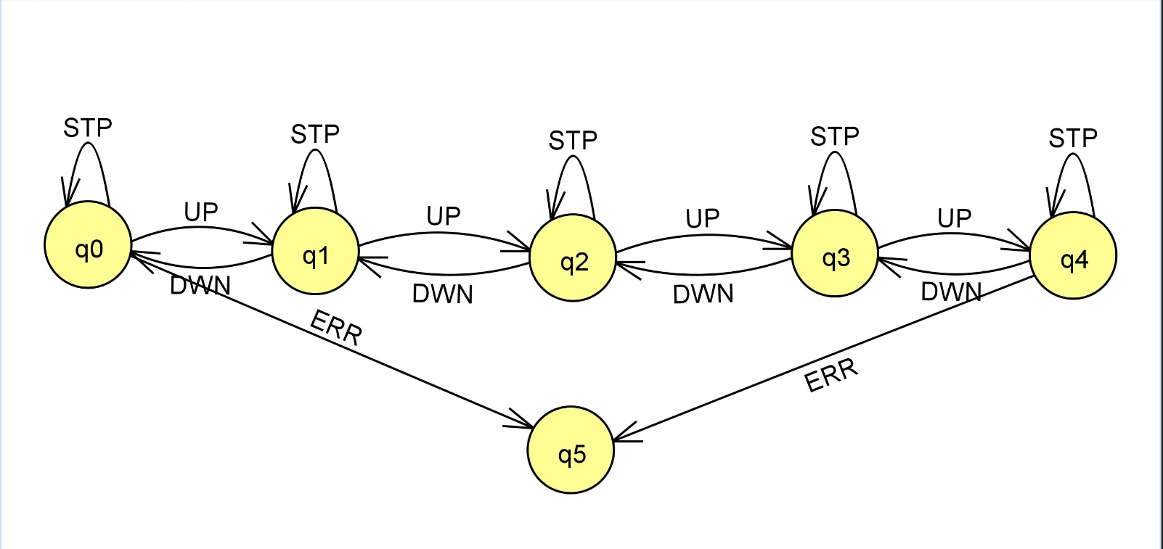

3.3 Transitions — Horizontal Chain (q0 ↔ q1 ↔ q2 ↔ q3 ↔ q4)
The five floor states form a linear chain. Bidirectional curved arrows between adjacent states represent UP and DWN transitions:

Arrow | Label | Meaning | Formal Notation
q0 → q1 | UP | Capsule fires upward thruster from F1 to F2 | δ(q0, UP) = q1
q1 → q0 | DWN | Capsule fires downward thruster from F2 to F1 | δ(q1, DWN) = q0
q1 → q2 | UP | F2 to F3 | δ(q1, UP) = q2
q2 → q1 | DWN | F3 to F2 | δ(q2, DWN) = q1
q2 → q3 | UP | F3 to F4 | δ(q2, UP) = q3
q3 → q2 | DWN | F4 to F3 | δ(q3, DWN) = q2
q3 → q4 | UP | F4 to F5 (Apex) | δ(q3, UP) = q4
q4 → q3 | DWN | F5 to F4 | δ(q4, DWN) = q3

3.4 Self-Loops — STP at Every State
Every state (q0 through q4) has a looping arrow back to itself labelled STP. This represents the STOP command engaging the magnetic docking clamps, holding the capsule in place without changing floor. In JFLAP these appear as small curved arrows above each circular node.
Formally: δ(qᵢ, STP) = qᵢ for all i ∈ {0, 1, 2, 3, 4}
3.5 Error Transitions — ERR Arrows to q5
Two long diagonal arrows point down to the trap state q5, labelled ERR:

- From q0 labelled ERR: This represents attempting to go DOWN from Floor 1 (the entry hatch). Since there is no floor below F1, the capsule breaches the lower airlock boundary. This maps to δ(q0, DWN) = q5.
- From q4 labelled ERR: This represents attempting to go UP from Floor 5 (the apex). Since there is no floor above F5, the capsule breaches the upper airlock boundary. This maps to δ(q4, UP) = q5.

Once in q5, the system is in a catastrophic failure (hull breach) from which it cannot recover without external reset. In the zero-G narrative, this represents catastrophic decompression of the containment vessel.

3.6 Trap State q5 — The Absorbing Error State
State q5 (q_err) has no visible outgoing transition arrows in the diagram to other states. This is because all transitions from q5 loop back to q5 itself — it is an absorbing state. Any input (UP, DWN, or STP) received while in the error state keeps the system trapped:

- δ(q5, UP) = q5
- δ(q5, DWN) = q5
- δ(q5, STP) = q5

This makes the DFA total — every state has exactly one defined transition for every input symbol. There are no missing transitions.

4. Complete Transition Table
The table below documents all 18 transitions of the DFA (6 states × 3 inputs). The → symbol denotes the start state; * denotes accepting states.

State | Label | Role | UP | DWN | STP
→ q0* | F1 Entry | Start + Accepting | q1 | q5 (ERR) | q0
q1* | F2 Low Orbit | Accepting | q2 | q0 | q1
q2* | F3 Mid Bay | Accepting | q3 | q1 | q2
q3* | F4 High Orbit | Accepting | q4 | q2 | q3
q4* | F5 Apex | Accepting | q5 (ERR) | q3 | q4
q5 | q_err Breach | Non-accepting Trap | q5 | q5 | q5

All 18 cells are defined. The DFA is total — a requirement for a formally complete DFA.
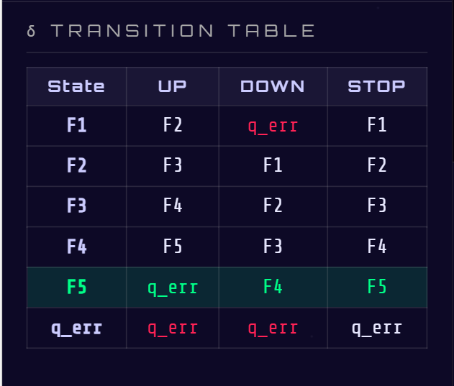

5. Formal Properties of the DFA
5.1 Totality
A DFA is total if δ is defined for every (state, symbol) pair. With 6 states and 3 input symbols, there must be 18 transitions. The table above confirms all 18 are present. The trap state q5 absorbs all invalid transitions rather than leaving them undefined.

5.2 Determinism
A DFA is deterministic if for each (state, symbol) pair there is exactly one next state. Inspecting the diagram and table: every cell has exactly one destination state — no cell is empty, and no cell has multiple options. The JFLAP Nondeterminism panel confirms this with no states highlighted in red.

5.3 Minimality — Myhill-Nerode Proof
A DFA is minimal if no two states are equivalent (indistinguishable). Two states p and q are equivalent if for every input string w, δ*(p, w) ∈ F ↔ δ*(q, w) ∈ F.

The six states fall into two equivalence classes before any analysis: {q0, q1, q2, q3, q4} (accepting) and {q5} (non-accepting). This immediately shows q5 is distinguishable from all others via the empty string ε.

Among the accepting states q0–q4, we use distinguishing strings:
- q0 vs q1: string DWN distinguishes them. From q0, DWN → q5 (reject). From q1, DWN → q0 (accept).
- q1 vs q2: string UP·UP·UP distinguishes them. From q1 → q2 → q3 → q4 (accept). From q2 → q3 → q4 → q5 (reject).
- Similarly, each adjacent pair is distinguishable by strings of appropriate length.

All 15 state pairs (C(6,2) = 15) are pairwise distinguishable. Therefore the DFA is minimal — no states can be merged and the 6-state automaton is the smallest possible DFA for this language.

5.4 Language Recognised
The DFA accepts all strings over {UP, DWN, STP} that represent valid elevator journeys — sequences that start at F1 and never attempt to go below F1 or above F5. The language consists of strings that keep the cumulative floor count n in the range [0, 4] at all times, where each UP increments n, each DWN decrements n, and STP leaves n unchanged.

6. Working of the System
The elevator begins at state q0 (Floor 1).
- When the UP command is received, it moves to the next floor.
- When the DOWN command is received, it moves to the previous floor.
- When STOP is pressed, the elevator remains at the current floor.
- If a command violates the boundary conditions, the system transitions to error state q5.
Example sequence:
Input sequence:
UP → UP → STP → DOWN
State transitions:
q0 → q1 → q2 → q2 → q1
This shows the elevator moving up two floors, stopping, and then moving down one floor.

7. Simulator Dashboard
The anti-gravity elevator DFA simulator is implemented as a single-file React application with a space-station visual theme. The dashboard is divided into several functional components, each explained below.

7.1 App — State Management Core
The root App component manages all state using React hooks:
- currentState — the active DFA state (q0 to q5)
- inputSequence — the list of commands entered so far
- path — the trace of states visited, shown in the DFA path panel
- verdict — Accepted or Rejected, computed after each step

The transition function δ is implemented as a JavaScript object lookup table matching the formal definition. When the user presses UP, DWN, or STP, the App component evaluates δ(currentState, input) and updates the state accordingly.

7.2 ZeroGElevatorShaft — Visual Shaft Rendering
This component renders the central elevator shaft — a vertical tube representing the zero-G containment vessel:
- The shaft is drawn as a tall vertical column with bold wall characters, giving the feel of an enclosed tube or airlock tunnel.
- Each floor (F1–F5) is shown as a docking bay with concentric ring visuals , representing magnetic alignment rings.
- The elevator capsule is rendered as a rounded rectangular box positioned at the current floor.
- Inside the capsule, animated particles in icy blue suggest floating debris — a microgravity particle effect.
- When the capsule moves, it drifts slowly and smoothly (low-thrust animation) rather than snapping instantly, reflecting zero-G propulsion.
- Airlock boundary markers appear at F1 (↓ ENTRY LOCK) and F5 (↑ AIRLOCK BOUNDARY) to visually indicate the out-of-bounds zones.

7.3 DFA Path Diagram — Orbital Arc Display
This component renders the state transition diagram with an orbital/space metaphor instead of simple flat arrows:
- States are shown as circular orbital nodes — each floor labelled with its zero-G role (Entry, Low Orbit, Mid, High Orbit, Apex).
- Transitions are drawn as arc-trajectory connectors suggesting orbital momentum rather than straight directional arrows.
- The currently active state is highlighted with a glowing pulse animation.
- STP self-loop edges pulse when the STOP command is triggered, visually suggesting the magnetic lock engaging.
- The path trace below the diagram shows the sequence of states visited, e.g. q0 → q1 → q2 → q1.

7.4 Control Panel — Input Interface
The control panel provides three interactive buttons corresponding to the input alphabet Σ:
- UP button — styled with thruster-glow cyan/green, triggers an upward thruster burst.
- DWN button — same thruster styling, triggers a downward thruster burst.
- STP button — styled with magnetic-lock amber, engages docking clamps and emits a lock symbol.

A Reset button returns the simulator to q0 (Entry Hatch F1) and clears the input sequence. The current input sequence is displayed as a running log of symbols.

7.5 BreachAlert — Error State Component
When the DFA enters q5 (the trap state), the BreachAlert component replaces the normal shaft view with a dramatic space-disaster display:
- A red blinking banner reads: ⚠ HULL BREACH — q_err ⚠ CONTAINMENT FAILURE.
- A decompression gauge slowly empties, indicating the cabin losing pressure.
- Curved air-leak visuals drift away from the capsule outline, suggesting escaping atmosphere.
- The entire component pulses with increasing urgency to signal the absorbing, unrecoverable nature of q_err.

7.6 PRD Section — Formal Documentation Panel
A collapsible section (Product Requirements Document) inside the simulator contains inline formal documentation:
- The complete DFA 5-tuple definition.
- The transition table.
- The Myhill-Nerode minimality proof.
- Viva Q&A notes addressing the zero-G design rationale.
- Test case results confirming accepted and rejected sequences.

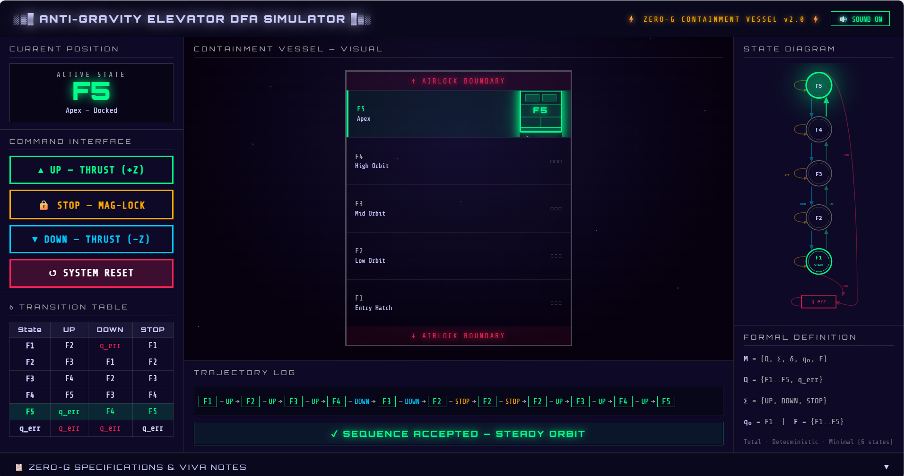

8. Test Cases — Accepted and Rejected Sequences
All test sequences produce identical results in both the original elevator DFA and the zero-G variant, confirming that the formal automaton is unchanged.

8.1 Accepted Sequences
Input Sequence | State Path | Final State | Verdict
UP UP UP UP | q0→q1→q2→q3→q4 | q4 (Apex F5) | ✓ ACCEPTED
UP UP STP | q0→q1→q2→q2 | q2 (Mid F3) | ✓ ACCEPTED
UP DWN | q0→q1→q0 | q0 (Entry F1) | ✓ ACCEPTED
STP STP STP | q0→q0→q0→q0 | q0 (Entry F1) | ✓ ACCEPTED
UP UP STP DWN UP | q0→q1→q2→q2→q1→q2 | q2 (Mid F3) | ✓ ACCEPTED

8.2 Rejected Sequences
Input Sequence | State Path | Trap Trigger | Verdict
DWN | q0→q5 | DWN from F1 — lower breach | ✗ REJECTED
UP UP UP UP UP | q0→q1→q2→q3→q4→q5 | UP from F5 — upper breach | ✗ REJECTED
UP UP UP UP DWN DWN DWN DWN DWN | ...→q0→q5 | DWN from F1 after descent | ✗ REJECTED

9. Conclusion
This project demonstrates that a formally correct Deterministic Finite Automaton can serve as both a rigorous theoretical model and the backbone of an immersive, interactive simulator. The anti-gravity elevator DFA preserves 100% of the formal automaton structure — total transitions, determinism, minimality, and trap-state correctness — while reimagining the physical and visual context as a zero-gravity containment vessel.

The JFLAP diagram confirms visual determinism (no highlighted nondeterministic states). The transition table accounts for all 18 state–input pairs. The Myhill-Nerode theorem proves minimality across all 15 state pairs. The simulator dashboard communicates all of these formal properties through an engaging space-station interface.

